**Registration Process for Allied academies**

1. **Open the Registration page.**

**Ex:** <http://psychiatry.alliedacademies.com/registration>



1. **Click on “Register for Conference” button. Then it will show you the registration page.**

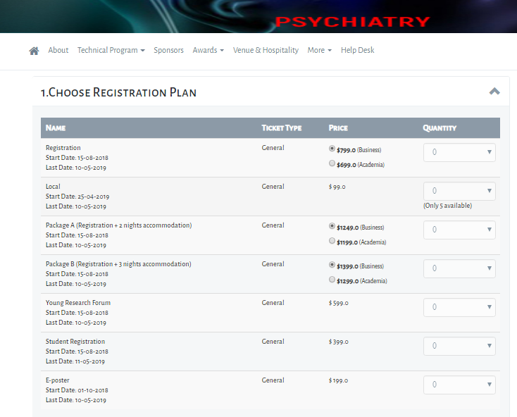

1. **Select the ticket quantity as per user requirement as shown below.**

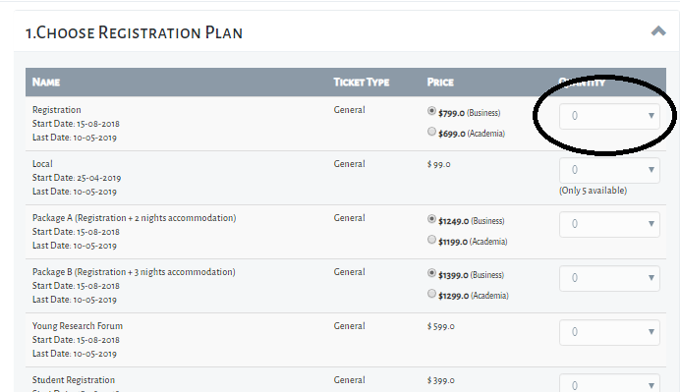

1. **After selecting the type of ticket and total count of the tickets, one call will rise for calculate the total price and final price.**

**EX:** [**http://psychiatry.alliedacademies.com/wu/getFinalPrice**](http://psychiatry.alliedacademies.com/wu/getFinalPrice)

1. **In this call it will calculate four parameters by contacting PriceBean.**

**private double totalPrice;**

**private double discount;**

**private double finalPrice;**

**private int totalTicketCount;**

1. **This PriceBean will contact RegistrationTicket (@Table(name = "regticket")) entity for calculating the above four parameters.**
2. **You will get the response as below. The final price will display at bottom of the page.**

**payload: {totalPrice: 799, discount: 0, finalPrice: 799, totalTicketCount: 1}**

**discount: 0 finalPrice: 799 totalPrice: 799 totalTicketCount: 1 status: "SUCCESS"**

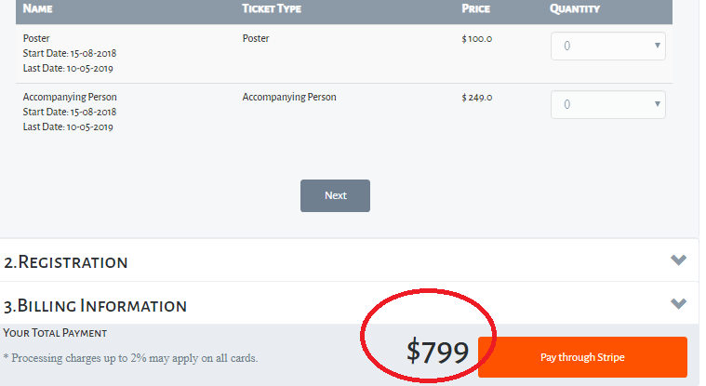

1. **Then we have two scenarios**
2. **Registered User.**
3. **Non Registered User.**
4. **If you click “Next” it will ask you about the login details:**

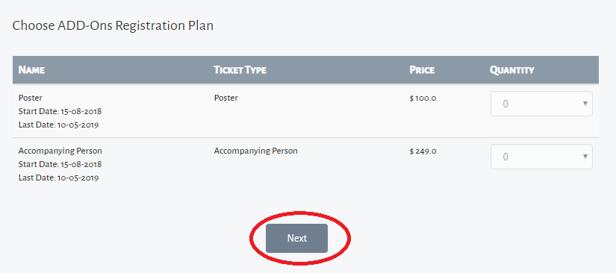

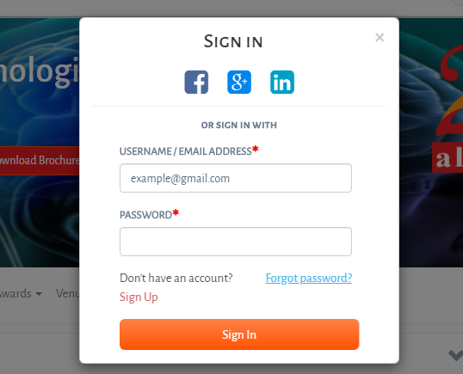

1. **If you click on “Next ” one call will raise to check whether the user is logged in or not.**

**Ex:** [**http://psychiatry.alliedacademies.com/wu/isUserLoggedIn**](http://psychiatry.alliedacademies.com/wu/isUserLoggedIn)

**This call will return the status whether user is logged in or not.**

1. **If the status is true will assign the details to the form parameters. No need to fill the details manually.**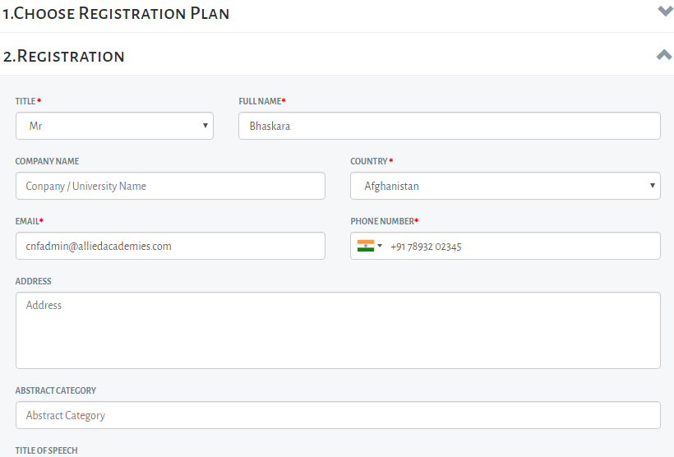
2. **If the status is false the user need to fill the details manually. Once fill the details click on “Next” . Then it will show you the billing address like below.**

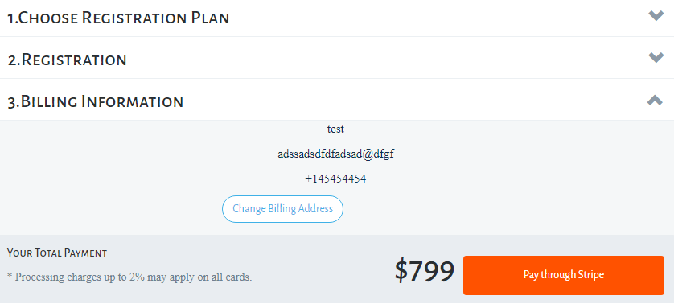

1. **Once click the “Pay through stripe” button one call will rise to store the registration details.**

**Ex:** [**http://localhost:8080/wu/register**](http://localhost:8080/wu/register)

**Once the call reaches the controller(WebUIService.java) ,**

**i.e. @RestController**

**@RequestMapping(value = "wu")**

**it will route to the relevant method.**

**i.e. @RequestMapping(value="register" ,method=RequestMethod.POST).**

**(@RequestBody RegistrationInput registrationInput)**

**The @RequestBody annotation binds the HTTPRequest body to the domain object. Spring framework automatically deserializes incoming HTTPRequest to the Java object using Http Message Converters.**

**registrationHandler.setupUserForRegistration(request, response,registrationInput);**

**In this step all the user details will be stored in user table. If the user is already registered it won’t save the details again.**

**Ie. insert into user (createdby, cts, deleted, modifiedby, mts, city, country, email, facebookid, googleid, ipaddress, linkedinid, logintype, majordiscipline, minordiscipline, mobile, name, password, phone, profileimagefileid, status, type, university, universityid, username, id) values (?, ?, ?, ?, ?, ?, ?, ?, ?, ?, ?, ?, ?, ?, ?, ?, ?, ?, ?, ?, ?, ?, ?, ?, ?, ?)**

**registrationHandler.register(registrationInput);**

**First validating the request will be done. Then**

**ConferenceRegistration savedRegistration = addConferenceRegistration(registrationInput**

**.getCnfRegistration());**

**In this call all the “registrationinput” parameters will be assigned to “ConferenceRegistration”.**

**Then save the below details in “cnfregistration” table.**

**Ie. insert into cnfregistration (createdby, cts, deleted, modifiedby, mts, abstractcategory, address, companyName, conferenceid, countryid, email, name, phonenumber, tickettype, title, titleofspeech, userid, id) values (?, ?, ?, ?, ?, ?, ?, ?, ?, ?, ?, ?, ?, ?, ?, ?, ?, ?)**

**After succefully inserting the details into “cnfregistration” , some details related to billing will be stored into “regbillinginfo”.**

**RegistrationBillingInfo savedRegBillingInfo = addRegistrationBillingInfo(registrationInput**

**.getRegistrationBillingInfo());**

**Ie.** **insert into regbillinginfo (createdby, cts, deleted, modifiedby, mts, abstractcategory, address, companyname, countryid, email, name, phone, registrationid, title, id) values (?, ?, ?, ?, ?, ?, ?, ?, ?, ?, ?, ?, ?, ?, ?)**

**(RegistrationTicket regTicket : registrationInput.getRegistrationTickets())**

**In this step registration ticket details will be override from “registrationinput” to “RegistrationTicket” , and store the overriding details into “regticket” table.**

**i.e. insert into regticket (createdby, cts, deleted, modifiedby, mts, discount, pricetype, quantity, registrationid, ticketid, ticketprice, totalprice, id) values (?, ?, ?, ?, ?, ?, ?, ?, ?, ?, ?, ?, ?)**

**After inserting regticket details , calculated some parameters like conferenceid, registrationid and registrationtype.**

**Ie.**  **registrationInput.getRegistrationPayment().setConferenceId( savedRegistration.getConferenceId());**

**registrationInput.getRegistrationPayment().setRegistrationId(**

**savedRegistration.getId());**

**registrationInput.getRegistrationPayment().setRegistrationType(**

**registrationInput.getRegistrationType());**

**After setting all these parameters to “registrationinput” one call will rise to save the registration details .**

**registrationPayment = addRegistrationPayment(registrationInput**

**.getRegistrationPayment());**

**Ie. insert into regpayment (createdby, cts, deleted, modifiedby, mts, conferenceid, discountcode, paymentgatewaytoken, paymentprocessed, paymentreceived, registrationid, registrationtype, totalprice, id) values (?, ?, ?, ?, ?, ?, ?, ?, ?, ?, ?, ?, ?, ?).**

**Here some empty fields are inserted for further responses.**

**Then it will display the payment gateway window. I .e**

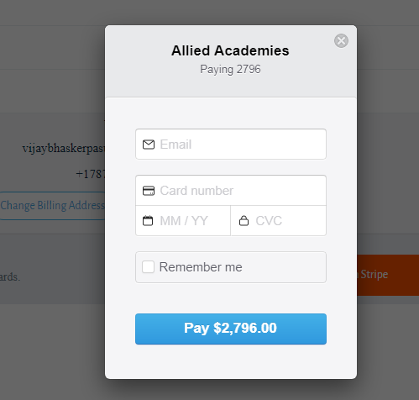

1. **After filling the card details you should click on “Pay” button. Then one call will rise**

**Ie. @RequestMapping(value="processPayment" ,method=RequestMethod.POST)**

**In this call all the registrationinput details will assigned to the following parameter.**

**@RequestBody PaymentGatewayInput paymentGatewayInput**

**After that one call will rice to process the payment.**

**i.e. registrationHandler.processPayment(paymentGatewayInput, request, response);**

**In this call it will detect what type of payment gateway using for payment process.**

**i.e. paymentUsingStripe(paymentGatewayInput, request, response);**

**Here all validations done related to payment. Once the payment process got success another call will rise for further payment updation process.**

**i.e. processPaymentSuccess(stripePaymentInput, request, response);**

**Here two parameters are retrived for RegistrationPayment.**

**i.e. long registrationId = paymentGatewayInput.getRegistrationId();**

**long conferenceId = paymentGatewayInput.getConferenceId();**

**By using these two parameters we are retriving particular registration record.**

**RegistrationPayment registrationPayment = registrationPaymentDAO**

**.getRegistrationPayment(registrationId, conferenceId);**

**And “regpayment ” table is updated with payment gateway status and payment gateway token.**

**Ie. update regpayment set createdby=?, cts=?, deleted=?, modifiedby=?, mts=?, conferenceid=?, discountcode=?, paymentgatewaytoken=?, paymentprocessed=?, paymentreceived=?, registrationid=?, registrationtype=?, totalprice=? where id=?**

**List<RegistrationTicket> regTickets = registrationTicketDAO**

**.getRegistrationTickets(registrationId);**

**In this call one registration ticket will retrived from the table “regticket ” based on registrationid.**

**And “cnfticket” table will updated with “TicketId” and “Quantity”.**

**Ie.conferenceHandler.updateTicketSoldCount(registrationTicket.getTicketId(),registrationTicket.getQuantity());**

**i.e. update cnfticket set createdby=?, cts=?, deleted=?, modifiedby=?, mts=?, academiaprice=?, businessprice=?, conferenceid=?, description=?, display=?, enddatetime=?, name=?, `order`=?, price=?, pricetype=?, startdatetime=?, status=?, tickettype=?, ticketsavailabilitycount=?, totalSoldTickets=? where id=?**

**After updation of cnfticket “ConferenceAttendees” object will be created in order for insertion of attende.**

**Here conferenceid and registrationid will be retrived from ConferenceRegistration and set to ConferenceAttendee.**

**ConferenceAttendees attendee = new ConferenceAttendees();**

**attendee.setConferenceId(registrationPayment.getConferenceId());**

**attendee.setRegistrationId(registrationPayment.getRegistrationId());**

**After setting up all the details related to registered user, one call will rise for insertion of cnfattendee. After successful insertion, Notification mail will send to registered user.**

**By Mahesh.**

**Allied WebTeam.**